ZD铸造铝合金
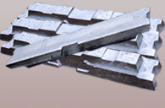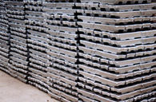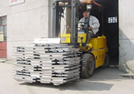
序号 | 合金牌号 | 合金代号
1 | ZA1Si7Mg | ZL101
2 | ZA1Si7MgA | ZL101A
3 | ZAlSi7l2 | ZL102
4 | ZA1Si9Mg | ZL104
5 | ZA1Si5Cu1Mg | ZL105
6 | ZA1Si5Cu1MgA | ZL105A
7 | ZA1Si8Cu1Mg | ZL106
8 | ZA1Si7Cu4 | ZL107
9 | ZA1Si12Cu2Mg1 | ZL108
10 | ZA1Si12Cu1Mg1Ni1 | ZL109
11 | ZA1Si5Cu6Mg | ZL110
12 | ZA1Si9Cu2Mg | ZL111
13 | ZA1Si7Mg1A | ZL114A
14 | ZA1Si5Zn1Mg | ZL115
15 | ZA1Si8MgBe | ZL116
16 | ZA1Cu5Mn | ZL201
17 | ZA1Cu5MnA | AL201A
18 | ZA1Cu4 | ZL203
19 | ZA1Cu5MnCdA | ZL204
20 | ZA1Cu5MnCdVA | ZL205
21 | ZA1RE5Cu3Si2 | ZL207
22 | ZA1Mg10 | ZL301
23 | ZA1Mg5Si1 | ZL303
24 | ZA1Mg8Zn1 | ZL305
25 | ZA1Zn11Si7 | ZL401
26 | ZA1Zn6Mg | ZL402

江苏宏博机械制造有限公司

总部地址:江苏海安南莫工业园区
董事长：韩青云 13906278039
生产科：赵 巍 13962782598

总部电话:0513-88475696 88473588
总部传真：0513-88473988

分部电话:0513-88482413 88482449
分部传真：0513-88485068

公司网址:http://www.hongbojs.com/
E-mail:zdly@zdly.com hb@hongbojs.com

